CRVS and Health Interoperability
This option integrates the different elements of the CRVS system with health information systems. Linking CRVS and health processes has the potential to maximise both health and CRVS outcomes. For example, birth registration can be linked to immunization records to increase the numbers of births registered and certificates issued. The CRVS and Health Interoperability and Data Exchange Architecture, described below, shows one way of achieving this. The basic architecture uses a combination of four tiers:

- Points of Service (PoS), comprising of CRVS and eHealth application software at various offices and health locations in the system providing information management.
- eGovernment Information Exchange (eGIE), comprising of a single, centralised set of applications providing core information management services and interoperability between PoS applications.
- Standards-Based Messaging providing a standardised way for different PoS applications to send and receive data from and through the eGIE.
- Security and Auditing between individual PoS applications and the eGIE elements, providing a foundation for control and management of the information flow.
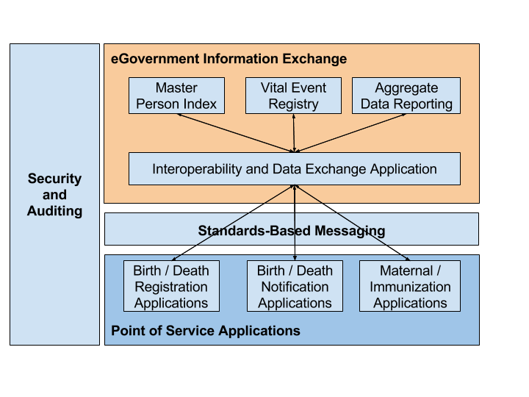
CRVS and Health Interoperability and Data Exchange Architecture

This 4 tier architecture applied to CRVS would consist of the following elements:

- An Interoperability and Data Exchange Application that facilitates communication between software applications and data at the point of service level and the central registries, index and data reporting applications. The application relies on standards to receive and route individual data elements through the eGIE, checking identifiers and populating registries.
- A Master Person Index that is used to manage multiple identifiers for particular individuals, including a national person identifier, a patient identifier, birth and death registration identifiers. All the identifiers can be linked together using a central internal master person identifier following best practices for creating identifiers.
- A Vital Event Registry (VER) that can be used to track vital and health events during a person’s life, e.g. birth, pregnancy, marriage and death. In each case, the vital event record is associated with a unique identifier stored in the Master Person Index.
- An Aggregate Reporting Application that can be used to aggregate individual record data and report statistical aggregates for vital events as well as aggregate health indicators. This application can also be used to collate data from the VER at any point in time, e.g. to create a Population Registry.
- Point of Service applications, such as Birth / Death Registration Applications, Birth / Death Notification Applications, Maternal / Immunization Applications that collect data in digital format at various points of service for local use as well as for transmission to a central point for information management and reporting.

