Project Initiation Document Template
Contents
Purpose 2
Document Change Control 2
2. Project Overview 3
2.1 Project Summary 3
2.2 Project Goals, Outcomes and Objectives 3
2.3 Project Scope 3
2.6 Project Cost Estimate and Source of Funding 4
2.7 Dependencies 4
2.8 Project Risks & Issues 4
4. Project Management Structure 5
5. Governance Structure 6
5.1 Roles & Responsibilities 8
6. Workplan 9
7. Project Management & Design Tools 10
8. Architecture Principles 10

[Note. All text in italics provides guidance on how to complete this template. It should be removed from the document prior to being made public.]

Purpose
Complete the below template, providing a clear statement of the scope, objectives and participants in the CRVS Digitisation Project.
The below Project Charter clearly outlines the scope, objectives and participants of the Analysis & Design Phase of the CRVS Digitisation Project. The scope defined here will be used throughout the Analysis & Design Phase to limit the occurrence of scope creep. The document will be reviewed and updated at the beginning of the Implementation Phase in order to reflect the shift in focus of activities and required project changes. To change the scope of the CRVS Digitisation Project, a Change Request will need to be raised and be reviewed and validated by the relevant project governance body (as defined in Roles and Responsibilities below).
The Project Charter is a document that formally authorizes the existence of a project, and provides the project manager with the authority to apply resources to project activities. The purpose of the Charter is to obtain formal approval on the goals, objectives, scope and structure of the proposed project, including:
- the project mandate, objectives and outcomes, benefits, scope and risks;
- the project deliverables, schedule, milestones, and estimated costs; and
- the project organization, governance structure and stakeholders.

Document Change Control
This section serves to control the development and distribution of revisions to the Project Charter. It should be used together with a change management process and a document management system. It is recommended that changes to the Charter are documented only by adding annexes to the original Project Charter. This will keep an accurate history of the original document that was first approved.
Revision History
Version No | Date | Brief Description of Change | Author

2. Project Overview

2.1 Project Summary
This section provides an overview of all activities within the Analysis & Design phase, highlighting the significant points of interest to the reader. It includes all of the information required for approval by the key stakeholders. The summary should also include some background information on the project that includes the reason/s for creating the project and mention the key stakeholders who will benefit from the project results:
- What mandate exists that requires you to digitise your CRVS processes; who granted this mandate?
- How and why the project was initiated?
- Who will fund this project?
- Who will use the final deliverable of the project?
- Who will be impacted by the project?

2.2 Project Goals, Outcomes and Objectives
This section describes the project goals and links each of them to related measurable project objectives. In addition, outcomes to be derived from the project goals and objectives should be presented as outlined in the CRVS digitisation business case. Measurement criteria, which will be used to confirm that an objective and the outcome have been reached, must also be provided.
Keep in mind that goals are high-level statements, usually broad general intentions that are typically intangible or abstract. Project objectives are concrete and measurement criteria usually confirm if an objective has been met. Outcomes are results expected at the end of the project.
Add rows as required.
No. | Goals | Objectives | Outcomes
1 |  | · | ·
2 |  | · | ·
3 |  | · | ·

2.3 Project Scope
This is a high-level description of the features and functions that characterize what is expected to be delivered by the project i.e. each activity included in the Analysis & Design Phase of this Guidebook.
Activities In Scope | Activities Out of Scope
1. | 1.
2. | 2.
3. | 3.

2.6 Project Cost Estimate and Source of Funding

2.6.1 Project Cost Estimate
This is where you record a summary of cost estimates for all of the resources (human, material and financial) required to produce the deliverables and meet the objectives established for the project.

2.6.2 Source of Funding
State the various sources of funding that will be used to support the project. It should be clear to the project sponsor and the project manager where the funds come from and the level of resources committed to this project.

2.7 Dependencies
This is where you list dependencies for the project e.g. a predecessor/successor relationship exists with another project (MOU, partnerships, etc.): A related project expects a deliverable from your project; this project expects a deliverable from a related project; etc.
Dependency Description | Critical Date | Contact

2.8 Project Risks & Issues
Identify key risks and issues that affect the Analysis and Design Phase of the CRVS Digitisation Project. Each risk and issue should be ranked in terms of probability and impact and a mitigation action should be documented in order to lessen the impact or lower the probability of the risk/issue taking place. The table below can be used to log these risks and should be maintained throughout the process.
No. | Risk Description | Probability  (H/M/L) | Impact  (H/M/L) | Planned Mitigation | Owner
1
2
3

4. Project Management Structure
Add, edit, and/or update the below table, identifying key resources who will be responsible for clearly defined activities within the project.
All actors that will work in the CRVS Digitisation Project Team during the Design and Analysis phase are listed below.
Role | Description
Project Manager | Responsible for the effective and efficient day to day planning and implementation of the project under the overall guidance and supervision of the Project Steering Committee. The PM will ensure the functioning of the project from beginning to the end including project inception activities, planning and reporting, and implementation of project activities, project reviews and project closure.
Business Analyst | The Business Analyst (BA) is able to analyse the organisation and business domain (i.e. CRVS) and document its processes and systems and assess how technology systems can support the business need. The BA has the responsibility to ensure that ICT solutions address business goals and objectives (e.g. reduction in costs, increased efficiencies) by defining the business and functional requirements for the system.
CRVS Subject Matter Expert | The Civil Registration Expert is a CRVS expert who has an extensive, in-depth knowledge and experience of the overall national civil registration process, and understands the legal, operational and human resource aspects. The Civil Registration Expert applies this expert knowledge to all steps in the CRVS digitisation process, checking that the other non-CRVS specialists working on the team understand the specialization necessary to make solutions appropriate to the domain of CRVS.
Government IT Subject Matter Experts | Senior government official representatives who have deep technical knowledge of the country’s IT systems in the government of the country in which the CRVS system(s) will be implemented. This should include in-depth technical knowledge of the systems that directly support CRVS as well as systems in other departments and ministries, including the ministries of interior, home affairs, justice and health (or equivalent). They should be well versed in the country’s IT strategy and related initiatives e.g. eGovernment strategy.
Solution Architect | The Solution Architect is responsible for overall system design and the development of a system architecture based on functional and non-functional requirements documented by the Business and Systems Analysts. The design and architecture is then used by the rest of the development team to implement the solution.
Project Sponsor | The Project Sponsor is usually a senior government representative who directly commissions the CRVS digitisation project, reports to the director/executive and coordinates national level CRVS activities including the steering committee, and acts as a vocal and visible champion, legitimising the project’s goals and objectives. The Sponsor is also responsible for setting project priorities, securing project funding; allocating project resources; final approval of all deliverables; approving the contracts (if applicable) and national level directives and communications.
End User Representatives | Represent the different types of end users who will interact with the system. Play a vital role in establishing the requirements of the system and providing feedback during requirements validation and system prototyping.

The diagram below shows the project’s Project Management Structure, clearly demonstrating relationships between each team member, and reporting and escalation routes that will be used for day to day decision-making activities.

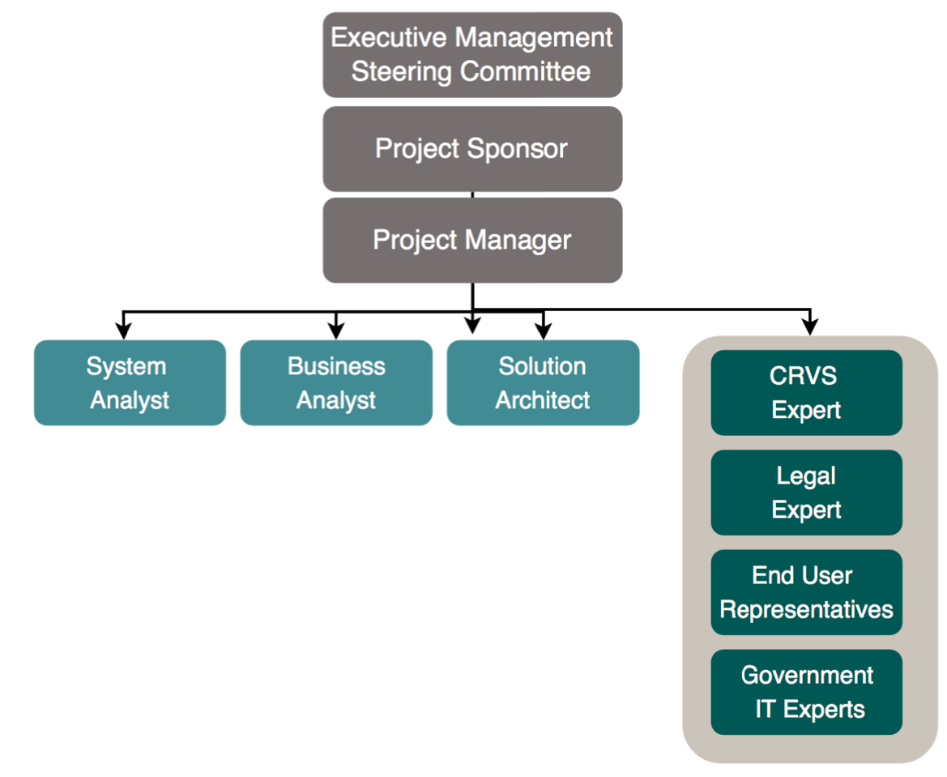

5. Governance Structure
Update the below table with country-specific titles; this will inform how and when each group should be involved in the project and what responsibilities they should have.
Member | Interests | Objectives
Name of individuals/groups | What interests do they have in being involved in CRVS Digitisation? | What are their specific objectives for the CRVS Digitisation project?
CRVS Steering Committee | Responsible or project governance, decision-making | Improved outcomes from investment.  Project implemented on time, within budget, and meeting user requirements
Civil Registration Agency | “Owns” the system | Delivery of a system that meets their requirements with acceptable usability, performance, and flexibility.
Vital Statistics Agency | Improved ability to produce vital statistics derived from vital event data | Delivery of accurate, timely and complete vital statistics from CR system
Ministries of Home Affairs, Finance, Justice, Health, Education, etc. | Improved ability to share data | Improved outcomes from investment. Integration with existing systems. Harmonisation with other projects.
Ministry or department of IT or Planning | Ensuring project complies with policies and standards. Responsible for infrastructure. | Alignment of project with the national eHealth strategy and compliance with policies. Ensuring the project leverages existing investments in IT servers, communication networks, etc.
Project team | Meeting short-term criteria set by project sponsors and the funding organization. | Successful delivery of the project implemented on time, within budget, and meeting requirements.
Subcontractors | Clear terms of reference and acceptance criteria. Timely payments for services delivered. | Deliver products or services according to agreed contracts terms.
Vendors | Establishment of a long-term revenue stream. | Deliver products or services according to agreed contracts terms and build long term relationship.
Funding sponsor |  | Lasting impact and demonstrated value for money of the project.
Non-governmental organisations | Provide specialist expertise | Successful delivery of the project and realisation of benefits
Citizens | Improved CR service delivery

The diagram below shows the Project’s Governance Structure, clearly demonstrating relationships between key project stakeholders, and reporting and escalation routes that will be used for key decision-making activities.
Insert organisational design diagram below to represent the Governance structure. This diagram should clearly demonstrate each actor, the relationships between actors, and who/what bodies they report directly into. Consider the questions included in Activity Analysis & Design 1: Initiate CRVS Digitisation Project, Step 3.

5.1 Roles & Responsibilities
Complete the below RACI matrix in order to clearly define each group/actors roles and responsibilities. RACI is an acronym that stands for responsible, accountable, consulted and informed. A RACI chart is a matrix of all the activities or decision making authorities undertaken in an organisation set against all the people or roles.
The RACI matrix below clearly defines each actor’s roles and responsibilities within the project’s Analysis and Design Phase.
Activities | Champion/sponsor | Funder | CRVS Steering Committee | Project Manager | Enterprise Architect | Business Analyst | Gov. IT experts | CRVS SMEs | Ministry Reps. | End User Representatives | NGOs | Citizens
Champion the project at highest level, align interests, resolve potential conflicts | A | I | C | C |  |  |  |  |  |  | C | I
Make key decisions | I | C | A,R | I | I | I | I | I |  |  | I
Manage funding | C | A,R | C | I |  |  |  |  |  |  | I
Plan, direct and manage day to day activities of the project
Define the Business Requirements | C | I | C | C |  | R | C | C | C | C | C | I
Identify relevant stakeholders for the As-Is Assessment | C | C |  | R |  | I | C | C | C | C | C | I
Document current CRVS processes and define digitisation requirements | C | I | I | A | C | R | C | C |  | C | C
Monitor and report progress | I | I | I | A,R | C,I | C,I | C,I | I |  |  | I
Validate requirements and provide feedback during design, development and prototyping |  |  |  | I | I | R | C | C | I | C | C
A RACI chart identifies who is Responsible, Accountable, Consulted and/or Informed

6. Workplan
Complete the below Workplan, ensuring that realistic timeframes are allowed for each activity.
 |  | Date (w/c) | 01-Jan | 07-Jan | 13-Jan | 19-Jan | 26-Jan | 01-Feb | 07-Feb | 13-Feb | 20-Feb | 26-Feb | 04-Mar | 10-Mar | 16-Mar | 23-Mar | 29-Mar |  | 04-Apr |  | 10-Apr |  | 17-Apr
 |  | Week | 1 | 2 | 3 | 4 | 5 | 6 | 7 | 8 | 9 | 10 | 11 | 12 | 13 | 14 | 15 |  | 16 |  | 17 |  | 18
Preparation Phase | Target Completion Date | Status
Define a long term vision and roadmap or CRVS Digitisation |  | Complete
Develop a Business Case for CRVS Digitisation |  | Complete
Analysis & Design Phase |  | Pending
Initiate CRVS Digitisation Project |  | Pending
Define the CRVS Business Architecture |  | Pending
Conduct an As-Is Assessment of the CRVS Landscape |  | Pending
Define CRVS Business Requirements |  | Pending
Identify CRVS Digitisation Opportunities |  | Pending
Define Target System Architecture |  | Pending
Document Target CRVS Processes |  | Pending
Define System Requirements |  | Pending
Governance |  | Pending
CRVS Steering Committee Meetings | Ongoing | In Progress
 |  |  |  |  |  |  |  |  |  |  |  |  |  |  |  | Key
 |  |  |  |  |  |  |  |  |  |  |  |  |  |  |  |  | Section Timeframe
 |  |  |  |  |  |  |  |  |  |  |  |  |  |  |  |  | Activity
 |  |  |  |  |  |  |  |  |  |  |  |  |  |  |  |  | Final Deliverable

7. Project Management & Design Tools
Complete below table, listing which tools have been identified to complete specific items.
The below tools should be used for all CRVS Digitisation Project Activities to ensure that common, consistent and high-quality outputs are produced by all actors involved.
Item | Tool
Process Maps | E.g. Bizagi
Word documents | E.g. Microsoft Word
Spreadsheets | E.g. Microsoft Excel
Document Repository | E.g. Dropbox. Provide link to document repository.
Reports | E.g. Microsoft Word
Presentation Materials | E.g. Microsoft Powerpoint

8. Architecture Principles
Edit, add, and/or update the below list of Architectural Principles that will be used to set architectural standards throughout the design and implementation phases.
The Architecture Principles below will be used to inform activities throughout the project lifecycle, providing a clear standard for all project outputs and deliverables.
Architecture Principle | Description
Business Principles
Primacy of Principles | These principles of information management apply to all organizations within the CRVS enterprise.
Maximize Benefit to the Enterprise | Information management decisions are made to provide maximum benefit to the national CRVS enterprise as a whole.
Business Continuity | CRVS operations are maintained in spite of system interruptions. There must be the capability to continue the business functions regardless of external events. Hardware failure, natural disasters, and data corruption should not be allowed to disrupt or stop CRVS activities. The enterprise business functions must be capable of operating on alternative information delivery mechanisms.
Common Use Applications | Development of applications used across the CRVS system is preferred over the development of similar or duplicative applications which are only provided to a particular organization.
Compliance with Law | CRVS information management processes comply with all relevant laws, policies, and regulations. E.g. e-Governance Framework, Civil Registration Code
Open Standards | CRVS systems utilise open standards that are publicly available for use and can be freely adopted, implemented and extended in order to support flexibility and sustainability.
Data Principles
Data Integrity | Maintain and assure the accuracy, consistency and completeness of CRVS data over its entire life-cycle
Data Security | Data is protected from unauthorized use and disclosure. In addition to the traditional aspects of national security classification, this includes, but is not limited to, protection of pre-decisional, sensitive, source selection-sensitive, and proprietary information
Data is an Asset | CRVS data is an asset that has national value and is managed accordingly.
Data is Shared | Users and citizens have access to the data necessary to perform their duties; therefore, data is shared across CRVS functions and organizations. Timely access to accurate data is essential.
Common Vocabulary and Data Definitions | Data is defined consistently throughout the enterprise, and the definitions are understandable and available to all users.
Application Principles
Technology Independence | Applications are independent of specific technology choices and therefore can operate on a variety of technology platforms. Otherwise technology, which is subject to continual obsolescence and vendor dependence, becomes the driver rather than the user requirements themselves
Ease-of-Use | Applications are easy to use. The underlying technology is transparent to users, so they can concentrate on tasks at hand.
Technology Principles
Requirements-Based Change | Changes to applications and technology are made only in response to business needs.
Control Technical Diversity | Technological diversity is controlled to minimize the non-trivial cost of maintaining expertise in and connectivity between multiple processing environments. Limiting the number of supported components will simplify maintainability and reduce costs.
Interoperability | Software and hardware should conform to defined standards that promote interoperability for data, applications, and technology.

