Business Process Modelling Guide

**Contents**

1 Process Modelling 1

1.1 Business Process Definitions 2

1.2 Types of Process 2

1.3 Levels of Maturity 2

1.4 Business Process improvement 3

2 Business Process Modelling Example 3

2.1 Business Process Modelling Symbol Key and Definitions 5

2.2 Business Process Modelling Definitions 5

3 Generic CRVS Business Processes 7

3.1 Generic Civil Registration Processes 8

4 Mapping Generic CRVS Processes to the Reference Guideline 9

5 Common Business Process Modelling Software Tools 11

# Process Modelling[1]

Process models represent a real-world process with the aim of:

* Understanding the business process by creating the model
* Creating a visible representation and establishing a commonly shared perspective
* Analysing the process flow and performance
* Representing a target process state

## Business Process Definitions

### Business Process

* A Business Process is a self-contained, logical set of activities performed by humans or machines that are executed to accomplish a specific business objective.
* Triggered by specific events and have one or more outcome that may result in the termination of the process or a handoff to another process
* Composed of a collection of interrelated tasks or activities that solve a particular issue
* End-to-end work that delivers value to customers and may involve crossing any functional boundaries

## Types of Process

### Primary (Core) Processes

Represent the essential activities that an organisation performs to fulfil its mission. These make up the value chain where each step adds value to the preceding step as measured by its contribution to the creation or delivery of a product or service, ultimately delivering value.

### Support Processes

These processes support the primary processes, often by managing the resources and/or infrastructure required by primary processes. Examples of support processes include information technology management, facilities or capacity management and human resource management.

### Management Processes

Management processes are used to measure, monitor and control business activities.

# Business Process Modelling Example

Business process modelling (BPM) is a method for representing the processes in a system. An example of how to model the business processes for a CRVS system is illustrated with a generic process in Figure 1, below, based on the Principles and Recommendations for a Vital Statistics System, Revision 3 (UNSD, 2014). The model was drawn in *Bizagi Modeler[2].*

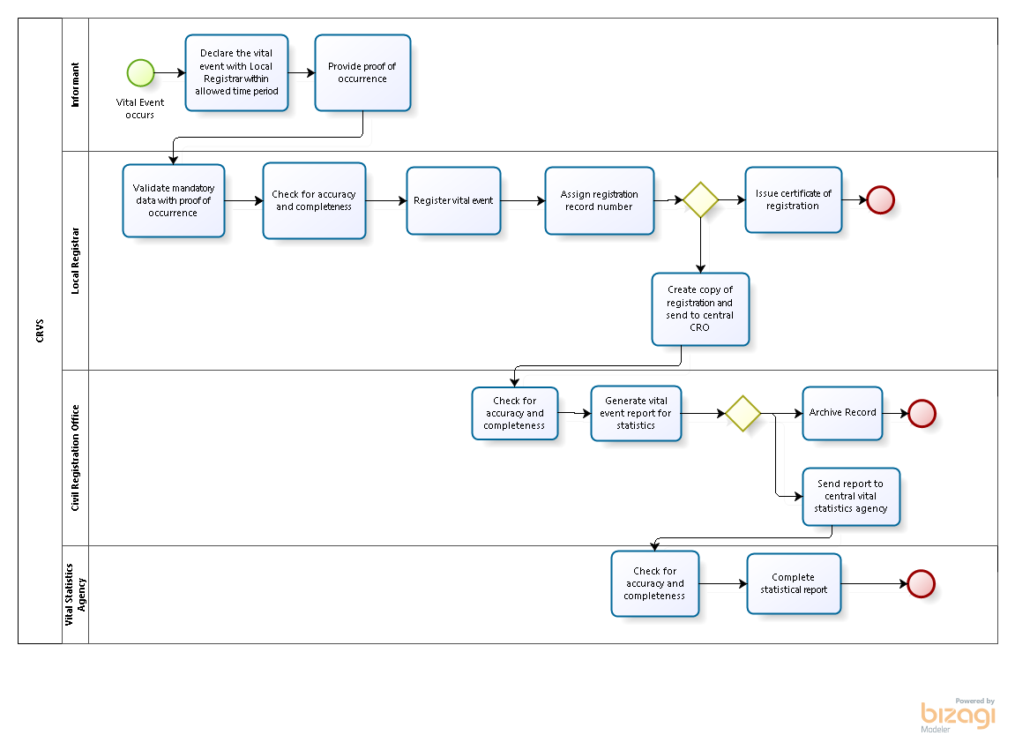

*Figure 1. Example CRVS Business Process.*

The BPM model should be read as follows (**Modelling Element Names are in Bold** and *Symbols in Italics*):

* The overall *Process Name* is **CRVS**. This information is used to label a *Pool* that refers to the overall business process. *Lanes* are used to describe each of the four main actors in the process, ie **Informant**, **Local Registrar**, **Civil Registration Office** and **Vital Statistics Agency**.
* The process begins in the **Informant** *lane* with the *Task* **Declare the Vital Event with Local Registrar within allowed time period**.
* This *Task* is followed by another *Task* by the **Informant** which is to **Provide proof of occurrence** with the relevant references to the reference which is continued through all the tasks.
* The *Process Flow* then switches to the **Local Registrar** *Lane* and the *Task* to **Validate mandatory data with proof of occurrence**. This is followed by *Tasks* to **Check for accuracy and completeness** and then to **Register the Vital Event** and then to **Assign Registration Record Number**. This is then followed by a *Gateway*. A *Gateway* reflects a split into two parallel directions. The first direction leads to the *Task* of **Issue Certificate of Registration**. The second direction leads to the *Task* of **Create Copy of Registration and Send to Central CRO**.
* The *Process Flow* switches to the **Civil Registration Office** *Lane* where there is another **Check for accuracy and completeness** Task followed by a Task to **Generate statistical report** followed by another *Gateway*. The first direction leads to the *Task* to **Send report to Vital Statistics Agency** and the second direction leads to **Archive** Record before terminating in a *Stop Event*.
* This *Process Flow* switches to the **Vital Statistics Agency** *Lane* where there is another **Check for accuracy and completeness** Task followed by a Task to **Complete statistical report** before terminating in a *Stop Event*.

## Business Process Modelling Symbol Key and Definitions

The most common business process modelling symbols are shown and described in the BPM Symbol Key and BPM Definitions, below:

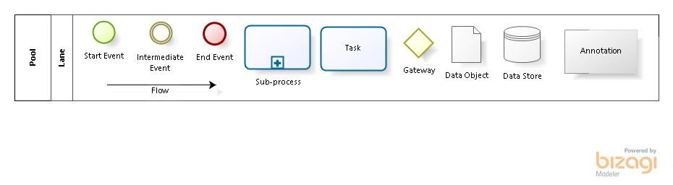

*Figure 2. BPM Symbol Key*

## Business Process Modelling Definitions

### Flow

Task

A Task is an atomic activity that is included within a process. A Task is used when the work in the Process is not broken. Generally, an end-user and/or an application are used to perform the Task.

Sub-Process

A Sub-Process object is and activity that contains other activities (a Process). The Process within the Process is dependent on the parent Process for its instigation and has visibility to the parent’s global data. No mapping of data is required.

Start Event

The Start Event indicates where a particular Process will start. In terms of Sequence Flow, the Start Event starts the flow of the Process and, thus, will not have any incoming Sequence Flow – no Sequence Flow can connect to a Start Event.

Intermediate Event

The Intermediate Event indicates where something happens (an Event) somewhere between the start and end of a Process. It will affect the flow of the Process but will not start or (directly) terminate the Process.

End Event

The End Event indicates where a process will end. In terms of Sequence Flow, the End Event ends the flow of the Process and thus, will not have any outgoing Sequence Flow - no Sequence Flow can connect from an End Event.

Gateway

Exclusive Gateways (Decisions) are locations within a business process where the Sequence Flow can take two or more alternative paths. This is basically the “fork in the road” for a Process.

### Data

Data Object

Data Objects provide information about how documents, data, and other objects are used and updated during the Process. While the name “Data Object” may imply and electronic document, they can be used to represent many different types of objects, both electronic and physical.

Data Store

A Data Store provides a mechanism for Activities to retrieve or update stored information that will persist beyond the scope of the process.

### Artefacts

Group

A Group object is an Artefact that provides a visual mechanism to group elements of a diagram informally.

Annotation

Text Annotations are a mechanism for a modeller to provide additional information for the reader of a BPMN diagram.

### SwimLanes

Pool

A Pool represents a Participant in the process. A Participant can be a specific business entity (eg a company) or can be a more general business role (eg a buyer, seller or manufacturer).

Lane

A Lane is a sub-partition within a Pool.

* 1. **Business Process Additional Information**

For each BPM documented, each process step should be documented with supplementary information (as per table below). The BPM and associated table provide a comprehensive view and description of the process that together effectively visualise and describe the process to facilitate analysis.

|  |  |  |
| --- | --- | --- |
| Name of process: Register Vital Event | | |
| Step | Actor | Additional Information |
| e.g. Declare Vital Event | e.g. Informant | e.g. Informant permitted to be x, y and x by law (insert law)  Declaration of vital event must take place at [location x] within a specified number of dates after the event has taken place  … |
|  |  |  |
|  |  |  |

*Table 1. Generic CRVS BPM Additional Information*

# Generic CRVS Business Processes

All CRVS business processes include a number of generic steps that should be included in one form or another. When modelling your processes, assess whether contextual versions of the steps listed below should be included in the model, as per Principles and Recommendations for a Vital Statistics System, Revision 3 (UNSD, 2014):

1. Civil Registration
   1. Declare Vital Event (including Notify and Record Vital Event)
   2. Validate Vital Event Data
   3. Register Vital Event
   4. Provide Certificate for Vital Event
   5. Generate Vital Event Data for Statistics Purposes
   6. Archive Vital Event Data
   7. Share Vital Event Data
2. Vital Statistics
   1. Compile Vital Event Data for Statistics Purposes
   2. Quality Control Vital Event Data for Statistics Purposes
   3. Generate Vital Event Data for Statistics Purposes
   4. Disseminate Vital Event Data for Statistics Purposes

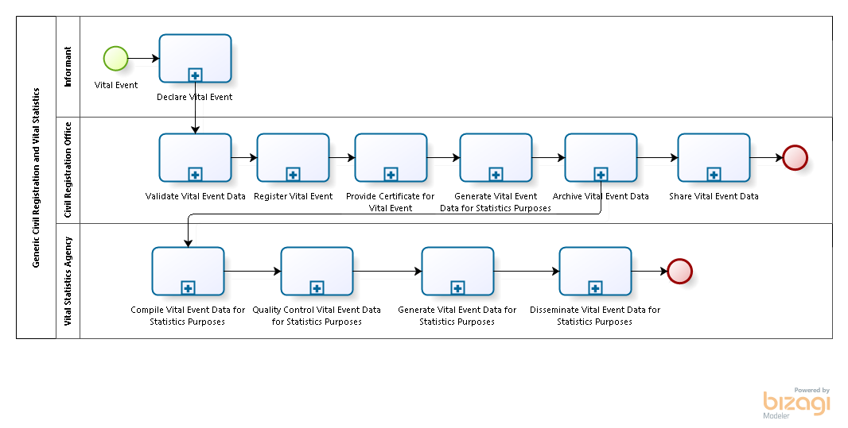

*Figure 3. Generic CRVS Business Model*

## Generic Civil Registration Processes

### Declare Vital Event

Civil registrars can legally register vital events only on the basis of an informant’s verbal or written declaration of the event [UNSD, 2014]. The informant is the individual or institution who, as required by law, reports or witnesses to the local registrar the occurrence of the vital event, its characteristics, the persons directly concerned with the event and their characteristics (UNSD, 2014).

### Validate Vital Event Data

Validation (verification) refers to the methods that can be used to assure the accuracy, validity and completeness of reported vital event data (UNSD, 1998c).

### Register Vital Event

A vital event registration record registers information on the occurrence of vital events as well as the persons related to the event. In the process of registration, a local registrar, prepares two documents, a vital event registration record and the corresponding statistical report (UNSD, 2014).

#### Amend (Correct) Vital Record

Amendments (corrections) to vital records refer to the process of altering an existing record to accommodate a clerical or other error. Corrections involving legal aspects of registration, such as dates of occurrence, usually require legal intervention while correction of simple clerical errors should be permitted without legal intervention. The legal system should specify the authority to make amendments and under what circumstances (UNSD, 2014).

### Certify Vital Event

Certification refers to the process of issuing certificates of Vital Events for legal, administrative and other purposes (UNSD, 2014). The certificates are legal proof of the occurrence of these vital events and provide statistical information to various government agencies and the general public.

### Generate Vital Event Data

Generation refers to the process of compiling data from individual vital statistics records for the purposes of internal reporting (within the civil registration service) or for sending to the agency responsible for compiling vital statistics. Generation may also include linking records within the vital registration system, eg linking infant death records to birth records by matching infant deaths in the death file with the corresponding record in the live-birth file. This allows information from the birth record, such as birth weight, gestational age and other characteristics of mother and infant at birth, to be combined with information from the death record, especially the cause(s) of death (UNSD, 2014).

### Archive Vital Event Data

Archiving refers to the process of storing and preserving vital event records. This includes both source documents and related or supporting documents both in paper and digital format (UNSD, 2014).

### Share Vital Event Data

Vital event data may be shared with other organisations, such as agencies responsible for maintaining the population register. Vital event data, such as marriages and divorces may also be shared, where they are maintained by a separate agency or ministry (eg justice).

# Mapping Generic CRVS Processes to the Reference Guideline

Table 2 shows the mapping between the generic high level business processes and paragraph headings from the Principles and Recommendations (UNSD, 2014).This mapping assists with guidance in terms of best practices for defining specific CRVS processes.

|  |  |  |  |  |  |  |  |  |  |
| --- | --- | --- | --- | --- | --- | --- | --- | --- | --- |
| **Principles and Recommendations for a Vital Statistics System, Revision 3** | | |  | **Civil Registration** | | | | | |
|  |  |  | **Declare** | **Validate** | **Register** | **Certify** | **Generate** | **Share** | **Archive** |
|  | **D. Principles of a vital statistics system** | **Clauses** |  |  |  |  |  |  |  |
|  | **5. Designation of a legally responsible informant for each type of event** | 349-355 | x |  |  |  |  |  |  |
| F. | **The Civil Registration Process** | 356-357 |  |  |  |  |  |  |  |
| 1. | Place of registration | 358-360 | x |  |  |  |  |  |  |
| 2. | Time allowed for registration | 361-363 |  | x |  |  |  |  |  |
| 3. | Cost of current registration | 364 |  |  | x |  |  |  |  |
| 4. | Proof required for the registration of vital events | 365-368 |  | x |  |  |  |  |  |
| 5. | Provision for late and delayed registration | 369-373 |  | x |  |  |  |  |  |
| 6. | The vital event registration record | 374-377 |  |  | x |  |  |  |  |
| 6.(a) | Ways and means of preparing records of vital events | 378-382 |  |  | x |  |  |  |  |
| 6.(b) | Storing and preserving records of vital events | 383-392 |  |  |  |  |  |  | x |
| 6.(b)(i) | Space and storage considerations | 383-384 |  |  |  |  |  |  | x |
| 6.(b)(ii) | Preservation methods and safety | 385-391 |  |  |  |  |  |  | x |
| 6.(b)(iii) | Need for central storage and preservation of vital records | 392 |  |  |  |  |  |  | x |
| 6.(c) | Storage and preservation of other related registration documents | 393 |  |  |  |  |  |  | x |
| 6.(d) | Recommended policies for the release of information on individual vital event records | 394-396 |  |  |  |  |  | x |  |
| 6.(e) | Content of the vital record for legal purposes | 397-399 |  |  | x |  |  |  |  |
| 6.(f) | Numbering vital records | 400-403 |  |  | x |  |  |  |  |
| 7. | Complementary notations (additions) in vital event registration records | 404-409 |  |  | x |  |  |  |  |
| 8. | Amendments (corrections) to registration records | 410-414 |  |  | x |  |  |  |  |
| 9. | Recommendations for issuing certified copies of vital event registration records | 415-418 |  |  |  | x |  |  |  |
| 10. | Linkages of vital records within the registration system | 419-422 |  |  |  |  | x |  |  |
| 11. | Linkages of vital records with records of other systems | 423-426 |  |  |  |  | x | x |  |
| 12. | Recording, reporting and collecting civil registration data for statistical purposes | 427-448 |  |  |  |  | x |  |  |
| 12.(a) | Types of statistical reporting forms and content | 427-434 |  |  |  |  | x |  |  |
| 12.(b) | The statistical reporting process |  |  |  |  |  | x |  |  |
| 12.(b)(i) | Principles of statistical reporting | 435-444 |  |  |  |  | x |  |  |
| 12.(b)(ii) | Improvement of completeness, accuracy and timeliness for statistical purposes | 445-448 |  |  |  |  | x |  |  |

*Table 2. Mapping between Generic Business Processes and main sections in the Principles and Recommendations (UNSD, 2014)*

# Common Business Process Modelling Software Tools

A number of different software tools are useful for modelling business processes and some of these are listed in Table 3, below. In general, we have listed tools that are simple to use, commonly used and either free or readily-available and affordable.

|  |  |  |  |  |
| --- | --- | --- | --- | --- |
| **Name** | **Description** | **License** | **Platform** | **Location** |
| Bizagi Studio | Simple flowcharting tool | FOSS | Microsoft | [www.bizagi.com](http://www.bizagi.com) |
| Bonita Studio | BPMN 1.1 modelling tool | FOSS | Open | [www.bonita.com](http://www.bonita.com) |
| Draw.io | Simple flowcharting tool | FOSS | SAAS | <https://draw.io> |
| Enterprise Architect | Database driven design tool | Sparx Systems | Microsoft | [www.sparxsystems.com](http://www.sparxsystems.com) |
| Google Drawings | Simple drawing tool | FOSS | SAAS | <https://docs.google.com/drawings> |
| Lucid Chart | Powerful drawing tool | Lucid | Open/SAAS | [www.lucidchart.com](http://www.lucidchart.com) |
| Visio | Powerful drawing tool | Microsoft | Microsoft | <https://products.office.com/en-us/visio/> |
| BPMN Stencils | BPMN 2.0 models in Visio | Orbus | Microsoft | [www.orbussoftware.com](http://www.orbussoftware.com) |

*Key: FOSS – Free and Open Source Software; SAAS – Software as a Service*

*Table 3. Details of Common Business Process Modelling Software Applications.*

1. The Section on Process Modelling was derived from a presentation prepared by Claudio Machado and the Book: Guide to the Business Process Management Common Body of Knowledge (BPM CBOK), Version 3.0.
2. [www.bizagi.com](http://www.bizagi.com)